Business Process Optimization
Model Fine Tuning (Qwen + LoRa)

Ameer Yousuf Ali Bhatti

My Work
My Git Repo
https://github.com/ameeryousuf/BPO-Model-Training

Notebooks
Dataset preparation —
/notebooks/5_prepareDataset.ipynb

Model Training —
/notebooks/6_modelTraining.ipynb

Model Inference —
/notebooks/7_modelInference.ipynb

Table of Contents
1.0 DATASET 4
2.0 Data Cleaning 5
3.0 Data Transformation 6
4.0 Model Selection & Training 9
5.0 Model Evaluation 11
6.0 Model Inference 12

1.0 DATASET
SAP SAM dataset, 1M real world BPMN models
Download dataset .zip file:
https://zenodo.org/records/7012043?preview_file=sap_sam_2022.zip

SapSam GitHub Starter Template:
https://github.com/signavio/sap-sam

SAP Signavio Academic Models: A Large Process Model Dataset — Paper: https://arxiv.org/abs/2208.12223

2.0 Data Cleaning
- Filtered BPMN 2.0 models
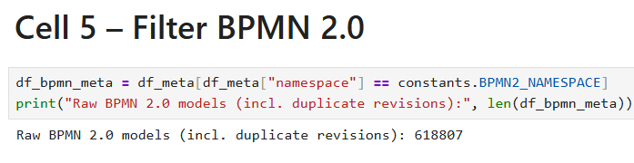
- Filtered example processes, Models with less than 5 elements, Model with no start, end and elements
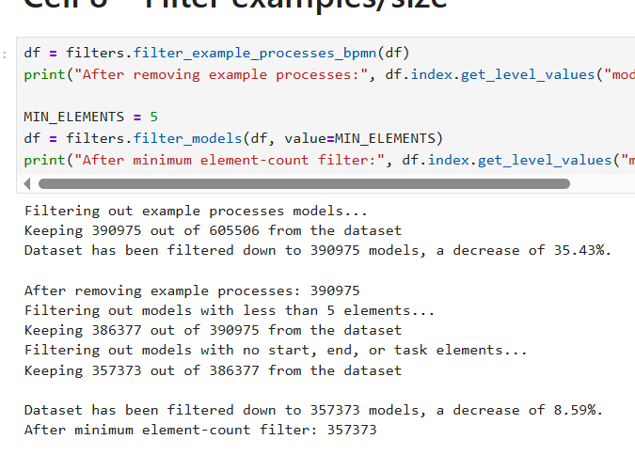
- Language detection, keeping English only models
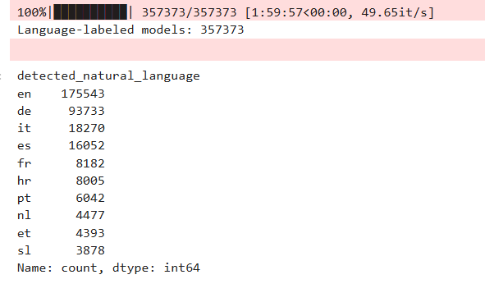

3.0 Data Transformation
- Converted models to our CMS Schema. (AS_IS) JSON.
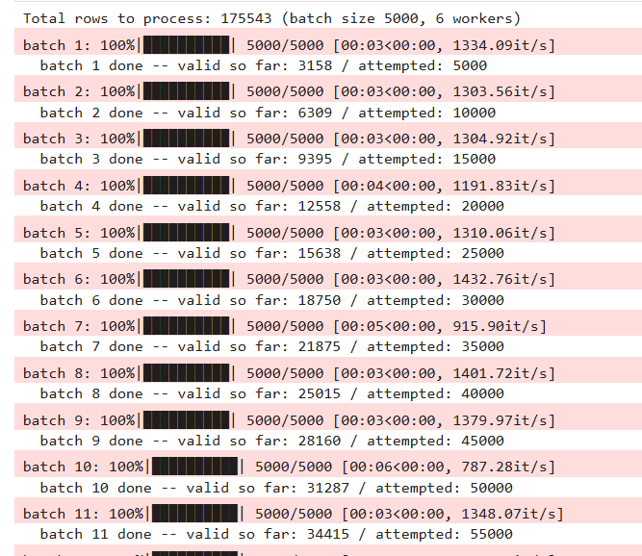
- Redesigned AS_IS JSON using reijers 10 heuristics by implementing condition they defined in second paper. This resulted in TO_BE JSON with redesign trace.
Heuristics Paper —
https://sci-hub.red/10.1016/j.omega.2004.04.012
Rules Paper — https://www.researchgate.net/publication/220710530_Performing_Business_Process_Redesign_with_Best_Practices_An_Evolutionary_Approach
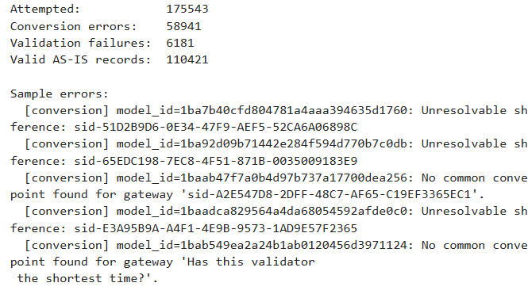
Train & Eval Split
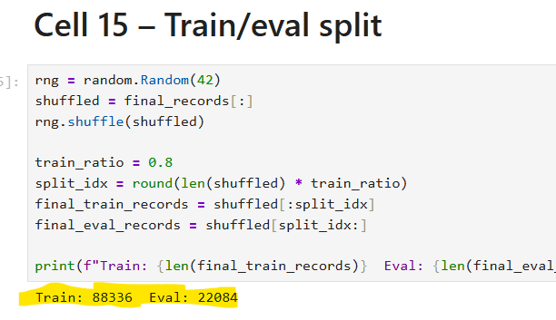
Summary
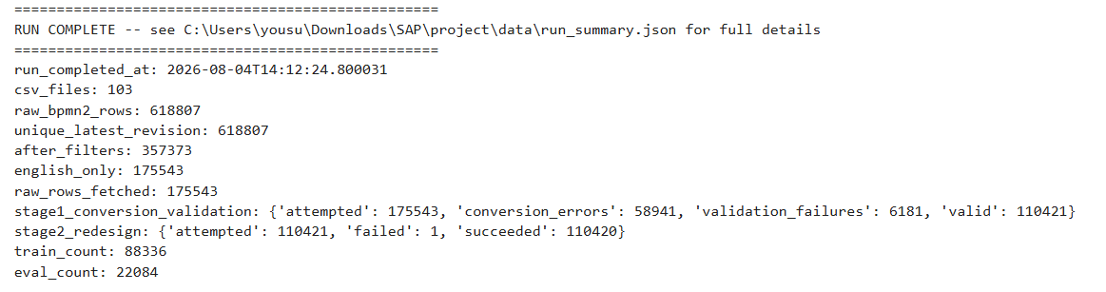
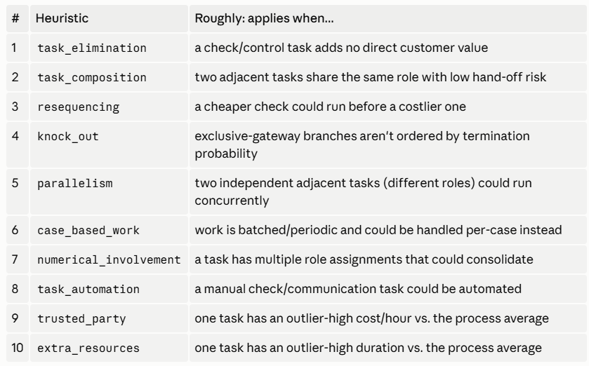
PC Specification Check
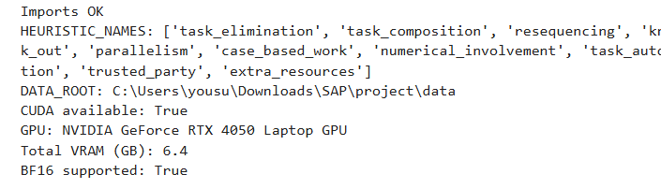

4.0 Model Selection & Training
Qwen/Qwen2.5-0.5B (base, not -Instruct) + LoRA was selected because this has 0.5B parameters. LoRA is well-suited to adapting a pretrained model to a narrow downstream task (10-way classification here) without needing to relearn general language understanding
Model Training
- Fetch Tran / Evaluation models from JSON dataset.
- Loaded sample 20K Train and 4K Evaluation.
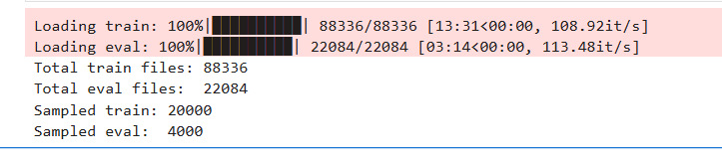
- Build Prompt + label builder
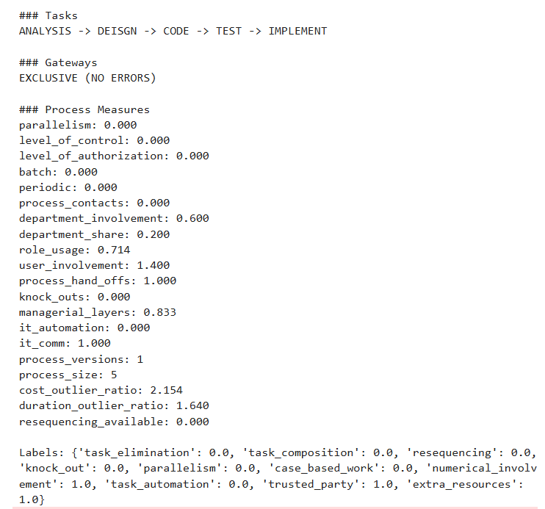
- Tokenize (fixed 284 len)
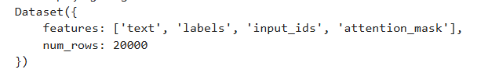
- Qwen 2.5-0.5B + Lora (SEQ_CLS, 10 labels)
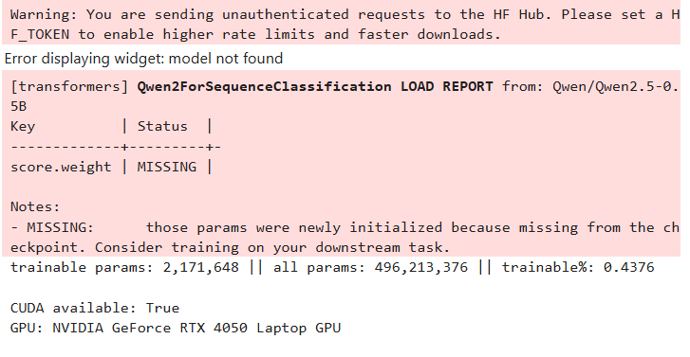
- Train (5 epochs) and Saved adapter.
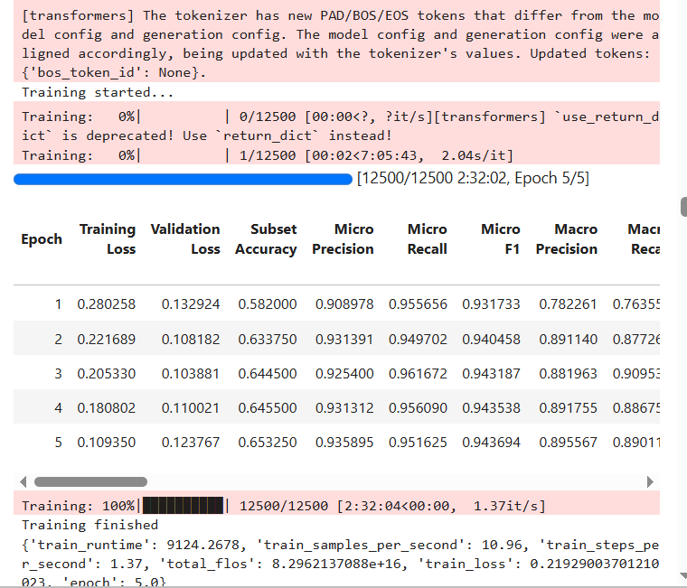

5.0 Model Evaluation
- Evaluate metrics.
- Predict labels on eval set.
- Executor (implemented predicted heuristics)
- Score (Cost / Time)
- Calculate P/R/F1 per heuristic
- Build overall training summary.
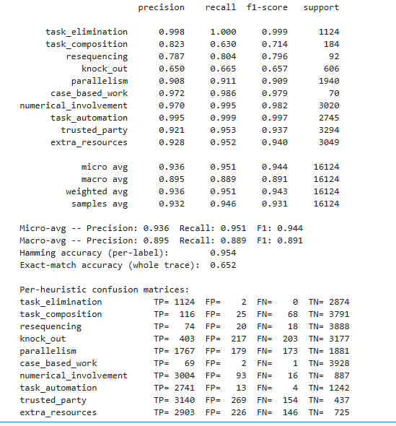
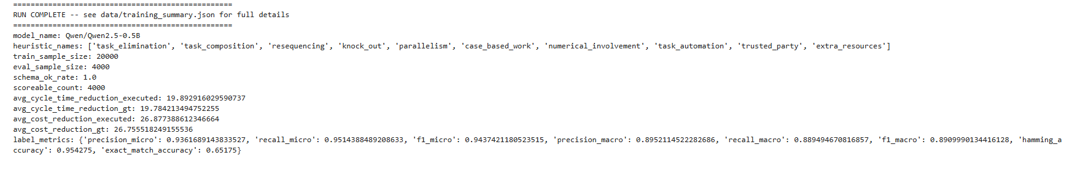

6.0 Model Inference
- Load base model + trained adapter
- Fetch 10 random models from eval folder
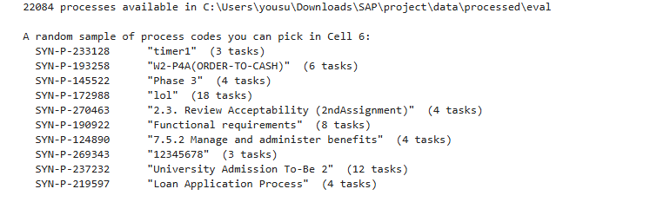
- Select one out of them
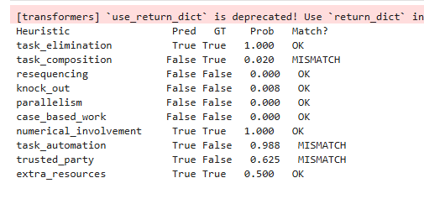
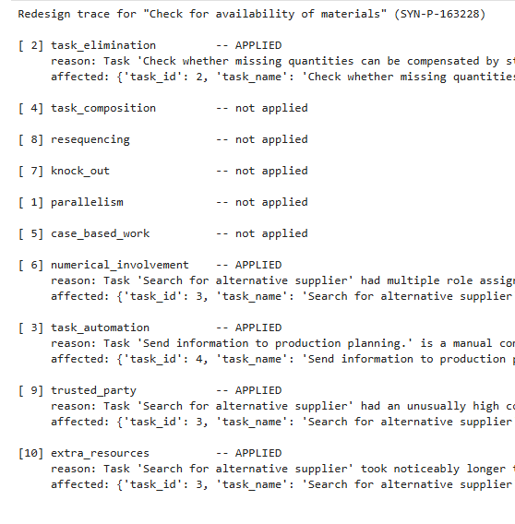
- See output in JSON
{
as-is: {
},
to-be: {
},
heuristicTrace: {
}
}
